Nama : Andang Sapto Pramono

NIM : L200150073

AlgoritmadanStruktur data

Perbandingan Sequential search,Sequential search(Sorting),Binary search,analisis Binary search

Sequential search

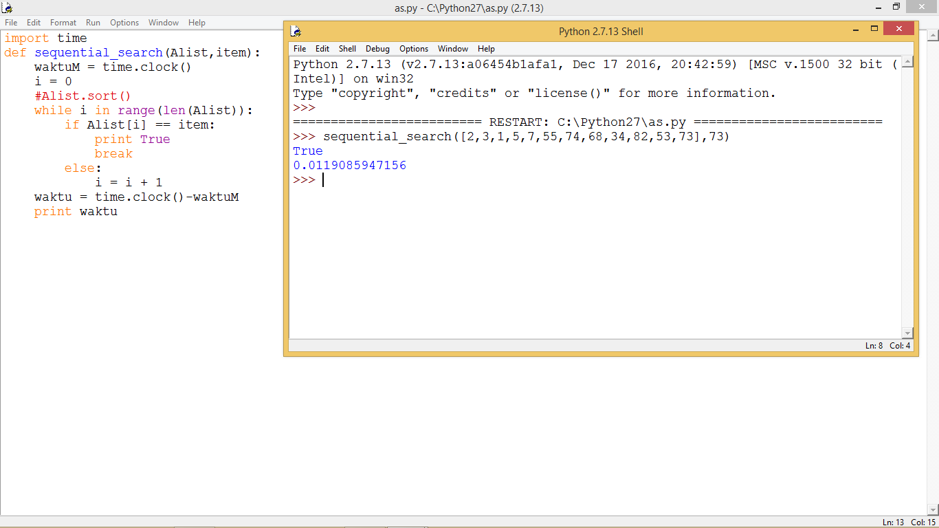

Sequential search (sorting)

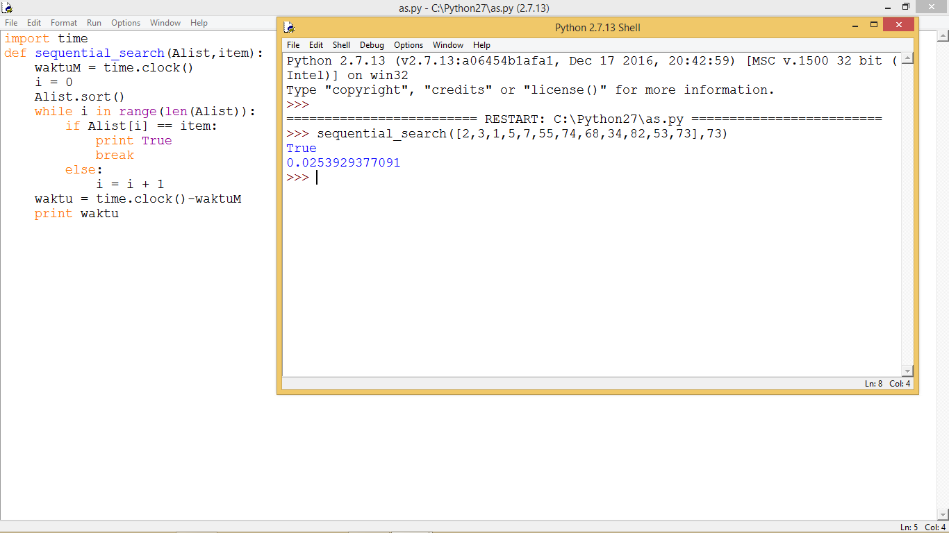

Binary searching

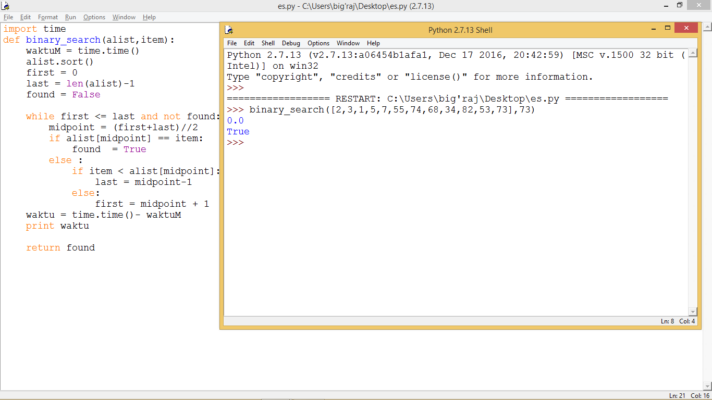

Analisis binary search